SIMPLE TRAMPOLINE BIOMECHANICS SUMMARY

THE APPLICATION OF BASIC MECHANICAL PRINCIPLES TO THE PERFORMANCE OF TRAMPOLINE SKILLS

Newton’s Laws of Motion
- 1st Law : Inertia
  - A body will continue in its uniform state of motion or rest unless acted on by an external force.
OR
  - A body at rest tends to remain at rest and a body in motion tends to continue in the same speed and direction unless acted on by an outside force.
- 3rd Law:
  - For every ACTION there is and equal and opposite REACTION. If you push down in the trampoline, the trampoline springs will then push you back up in the air with the same force.

- 2nd Law
  - The force needed to accelerate a body is directly proportional to the mass of the body and to the acceleration produced.
  - Acceleration is produced when a force acts on a mass. The greater the mass (of the object being accelerated) the greater the amount of force needed (to accelerate the object).
  - Everyone unconsciously knows the Second Law. Everyone knows that heavier objects require more force to move the same distance as lighter objects.
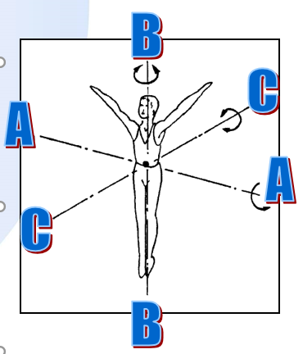
NOTE: All Axes pass through the centre of mass
Axes of Rotation
Any force acting around the centre of mass will cause rotation around that centre. ALL ROTATION IS CAUSED BY ECCENTRIC FORCE.
The Centre of Mass is the point around which a body will rotate. The axis is an imaginary line through the through the centre of mass of a body around which an eccentric force will produce rotation. There are 3 axes used in Trampolining.
- Somersault (Lateral) Axis:
- Twist (Longitudinal) Axis
- Side Somersault (Dorso-Ventral) Axis
Skills
Somersault axis | Twist Axis
- Front landing | - ½ twist
- Back Landing | - Full twist
- H & K Turnover | More than one axis
- Forward Turnover | - ½ twist to back
- Front SS | - ½ twist to front
- Back SS | - Full twist to…….
Torque/aerial twisting
Mass
- The weight of an object ignoring gravity
Velocity
- The speed at which an object travels
Acceleration
- The rate of change of velocity
Moment of Inertia
- A measure of the amount of work needed to produce rotation at a specific distance from the centre of gravity. As the mass of a trampolinist is unlikely to change during flight, this is usually taken as the largest distance of any mass from the centre of gravity
- This is the body’s resistance to somersaulting or twisting. If this is a low value (low resistance), you will somersault easily, i.e. when you are tucked for a forward s/s.
- If this is a high value (high resistance), you will somersault with difficulty, i.e. when you are straight in a s/s.
Momentum
- Energy stored in a body by acceleration does not disappear when you stop pushing, it is stored as potential energy and the body is said to have momentum
Forces
- Energy needed to produce an acceleration.
- Push & Pull
  - A force is needed to:
    - Start a motion
    - Change the rate of motion
    - Change the direction of motion
    - Cause motion to stop
- A force that passes straight through the CoM makes you move in a straight line
- Force = Mass x Acceleration, (see Newton's Laws) so, the harder you push, the faster you go
Eccentric [off-centre] force – is just simply a force that is NOT JUST UP AND DOWN.
- Any force applied to a body that does not pass through the centre of gravity will produce angular velocity around that centre. ALL ROTATION IS PRODUCED BY ECCENTRIC FORCE.
- It is a force that you apply in the trampoline bed for rotating forwards or
- backwards, i.e. when a performer does a front s/s the coach might say “dig your toes in” or “lift your heels” and this is what they are trying to get you to do in the bed.
Torque
- The Rotational push or pull
- Caused by a FORCE
- Eccentric or Off-Centre Force also called Torque
  - This will always create rotation
  - A torque whose line of action does not pass through the centre of mass of the body on which it acts
Inertia
- The resistance of a body to change
- Inertia is measured by Mass
- The reluctance for anything (including you) to start moving or stop moving when it is already moving. The greater the mass, the greater the reluctance to change, so the greater the force required to make a change.
- Examples:
  - (i) After an oil tanker has turned off it engine it will carry on drifting for miles.
  - (ii) A 12 stone coach may fairly readily support or catch a 7 stone jumper, but it would be irresponsible for a small 6 stone spotter to have much effect in catching a 12 stone faller.
Moment of Inertia
- The measure of the body’s reluctance to start rotating (or change direction) around an axis
Conservation of momentum
- Once you have left the trampoline you cannot create any more rotational energy.
- But you can control the speed at which you rotate
Change the moment of inertia
- Applies to all axes: Most relevant to twist and somersault!
- Twist – pull in arms – reduce moment of inertia around longitudinal axis – speed up (increase rotational speed) twist
- If a gymnast pulls in their legs on a front or back somersault after they take off they:
  - Reduce the moment of inertia and thus increase their rotational speed
  - NOTE NOT THEIR ANGULAR MOMENTUM
- If a gymnast extends their legs on a front or back somersault as they come in to land:
  - Increase the moment of inertia and thus decrease their rotational speed
  - NOTE NOT THEIR ANGULAR MOMENTUM

Newton's Law of conservation of momentum/inertia leads to the conclusion that, once a trampolinist leaves contact with the trampoline bed and is in flight, no other forces of note act upon him, and the actual value for Angular Momentum cannot change until he lands. Therefore, any change in Moment of Inertia must produce a corresponding change in Angular Velocity. Therefore, tucking up produces faster rotation than staying straight.

What you start with you stuck with. So if you take-off with not enough rotation for a s/s you are always going to land short.
Path of the centre of mass
- Your flight which is determined at take-off. If you take off so that you are flying off the trampoline, then there is nothing that you can do about it – you will still fall off.

Definitions (Linear Movement)
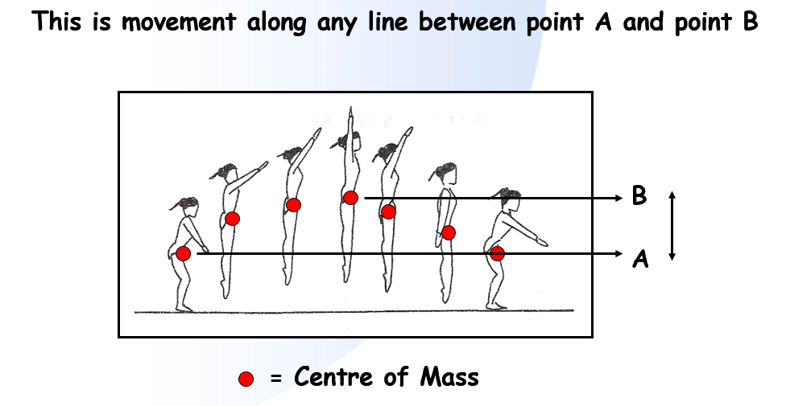
Centre of Mass
- Imaginary point which represents the 'middle' of the body's mass (size).
- The point at which your weight acts. Imagine if you were balanced at any angle on the tip of a sharp spear; this is the point at which you would balance perfectly. If you change your shape, your centre of gravity can move as well (and you could fall off).
Speed
- Rate of movement of the centre of mass.
Inertia
- A measure of the body's reluctance to start moving or change direction.
Momentum
- The amount of Linear movement in a body as it moves.
Conservation of Linear Momentum
- Linear momentum will remain the same until changed by an external force. (Newtons 1st Law)
- Changing Linear Momentum
- All changes in linear momentum are caused by external forces. These changes are determined by the size and direction of the force.

If a trampolinist is standing on the bed and wants to start straight bouncing, they exert a FORCE downwards with the muscles in their legs. This force overcomes the body’s INERTIA, and imparts MOMENTUM to the body as a whole (including the CENTRE OF MASS). As the trampolinist pushes harder into the bed, their linear SPEED increases.

Angular Movement
This is rotation around any axis. This can be considered separately to linear movement.
Remember rotation will always be around the CoM.
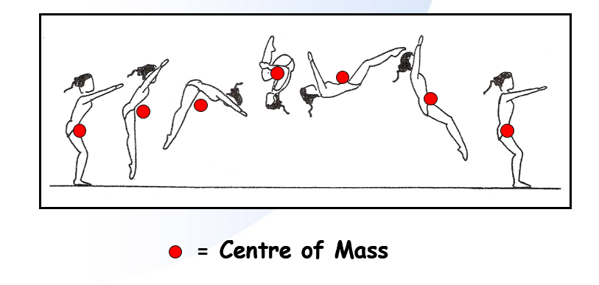
Axes
- Imaginary lines through the body, around which the body can rotate.
Angular Speed
- Rate of rotation around an axis (e.g. 360° per second around the somersault axis).
Moment of Inertia
- A measure of the body's 'reluctance' to start rotating (or change direction) around an axis.
Angular Momentum
- The amount of rotational 'energy' in the body as it rotates around an axis.
Torque
- The rotational push or pull caused by a linear force.
If a trampolinist is already straight bouncing and wants to create a somersault, they exert an off-centre force which creates TORQUE. This torque overcomes the body’s MOMENT OF INERTIA, and imparts ANGULAR MOMENTUM to the body around the somersault AXIS. If the trampolinist creates a larger off-centre force, their ANGULAR SPEED and ANGULAR MOMENTUM will be greater.

Conservation of Angular Momentum
- Angular momentum will remain the same until changed by an external torque.
Changing Angular Momentum
- All changes in angular momentum are caused by external torques. These changes are determined by the size and direction of the torque.
Controlling Angular Speed
- During flight, angular speed can be controlled by changing the moment of inertia. This can be done by tucking, piking or straightening the body.
Off -Centre Forces
- The body generates rotational forces through friction between the performers feet and the bed. This imparts rotation through the hips as the performer rotates.

REMEMBER: MOMENTUM IS FIXED ON TAKE OFF (Newtons 1st law).
- The path of the Centre of Gravity is fixed at take-off and cannot be altered in flight ( unless by an external force interrupting eg: coach or spotter.) Thus when you have left the bed, you are going where you are going and whatever you do in the air cannot affect this. Changing the body shape in the air (tucking, piking, dropping the head and shoulders, lifting the legs, cannot create rotation etc.(Can however, create twist!)
- HOWEVER, Reducing the moment of inertia increases the angular velocity whilst Increasing the moment of inertia decreases the angular velocity (NOTE VELOCITY NOT MOMENTUM).
Transfer of momentum
- If a moving body collides with a stationary body, both bodies will end up moving because some of the momentum of the moving body is transferred to the stationary body.
- In any interlocking system, such as our own bodies, if any part of the system is moving, its momentum can be transferred to the whole body by immobilising the point where the moving part attaches to the rest. This concept is very important to the understanding of Back and Front drops.

GENERAL MECHANICAL PRINCIPLES WHICH NEED TO BE CONSIDERED
Twisting is always best done straight.
All Somersault rotation is created at the take off phase.
  - An off centre force (torque) is applied around an axis of rotation
  - Rotation occurs around the centre of mass
  - Rotation is initiated whilst in contact with the bed and the amount of somersault/Angular Momentum is then fixed as a result of the OFF CENTRE FORCE applied.
  - An off-centre force must be created and applied whilst in contact
  - with the trampoline. It can’t be created in mid-air. Once you have taken off, you can only change the angular velocity (speed of rotation) by changing the shape of the somersault, i.e. if you tuck it will speed up

Take-off is the most important part of any skill
- Without a good take-off, the skill cannot be performed correctly
- Leaning must be discouraged since it creates Travel (Newton’s 1st law), loss of height and rotation (Eccentric or Off-Centre Force)

