QUALITY AND PROFICIENCY SCHEME
Execution judges look for…..
- four key areas
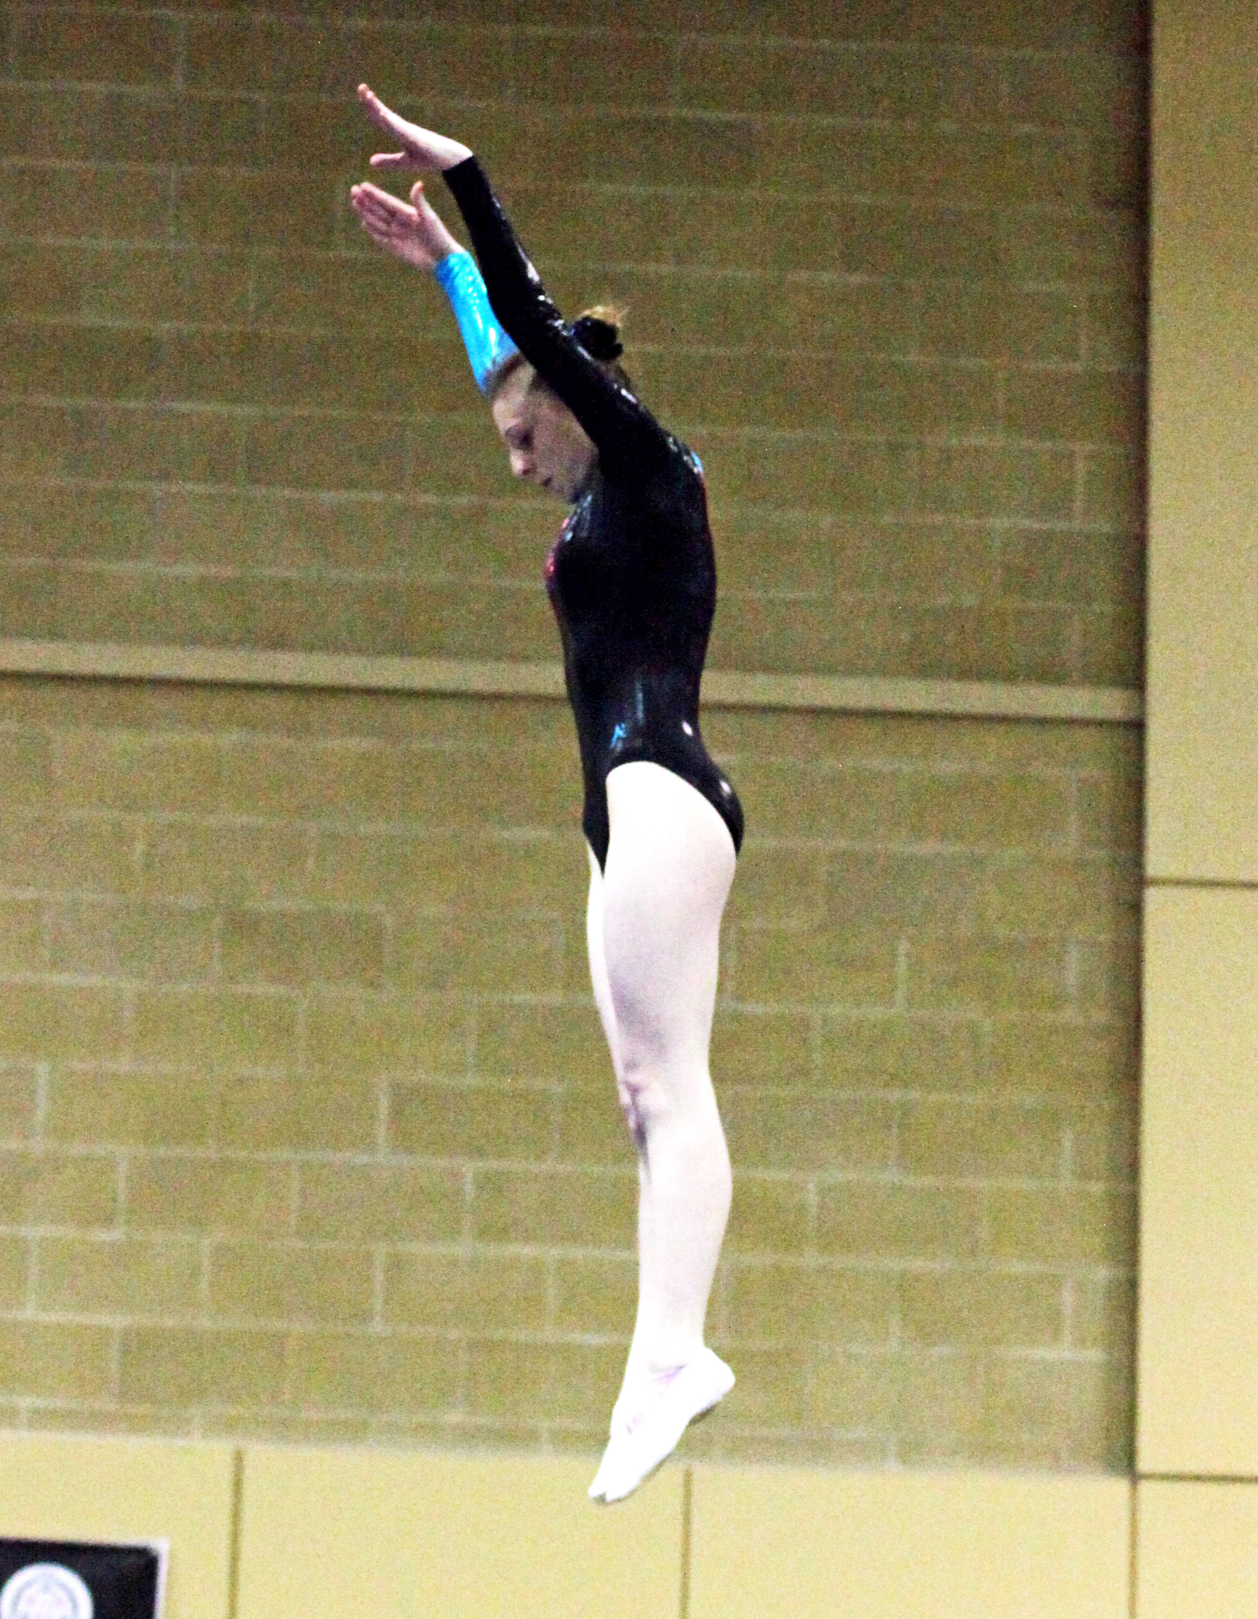
- Take off’s
- Shapes
- Twists
- Exits
Perfection
- Straight at take off
- Delay before the shape
- No travel
- Deep shape - no arched body
- 12 o’clock exit
- Body held straight all the way into the bed
- Twists completed before the final phase
- Pointed fingers and toes, head aligned

Next Step Trampoline Competition
  - The Next Step Gymnastics competition resource targets Key Stages 3-5 with discipline specific skills.
  - Flexible competitive format
  - Gymnastics competition portfolio
  - BG recommended competitive format for the use by: Competition Organisers, Secondary Schools, Clubs, Colleges, Partnerships and Leisure Centres.
Pack contains
- Introduction
- Formats for competitions
- Body management routine cards
- Discipline specific packs containing:
  - work cards
  - DVD
  - A2 sized posters showing routines
  - Guidelines on how to set up and judge a competition
  - judging score sheets
- General advice on managing ad running gymnastics competitions, officiating, use of volunteers and leaders
- Template for score sheets, competitions programme, and invitation letters

Proficiency Award Schemes
- Trampoline Awards 1-9
  - UKCC Level 1 - Assistant Coach
  - Available from BG – 0845 1297129 ext 2355
- Trampoline Awards 10-13 (and bits of 14)
  - UKCC Level 2 - Trampoline Coach
  - National competition structure
    - Grades: Regional G - Regional D
    - Info available from www.bg-coaches.org
